Documentation
Of
LTS-Net: A Temporal Transfer Learning Framework for Cross-Year Landslide Segmentation

Worked Under the Supervision
Of
Dr. Yunus Ali Pulpadan
Assistant Professor , Earth and Environmental Science {EES} , IISER Mohali

By
Atrii Roy
3rd Year BS (Hons.) DSAI , IIT Guwahati

Abstract
This study introduces LTS-Net (Landslide Temporal Segmentation Network) — a deep learning framework for automated landslide detection and segmentation using PlanetScope 8-band multispectral imagery.
The framework evaluates five architectures — U-Net, ResU-Net, Attention U-Net, Attention ResU-Net, and ASDMS U-Net — under cross-year transfer learning conditions, where models trained on 2024 satellite data are tested on 2022 imagery from the same terrain (Villangad region, India).
Results demonstrate that ResU-Net achieves the best overall performance with 0.9779 accuracy and 0.8321 F1-score, highlighting its superior temporal generalization ability.
This work emphasizes the potential of residual and hybrid deep architectures for temporal domain adaptation in geospatial hazard monitoring.

Introduction
Landslides are among the most destructive natural hazards, causing significant loss of life, property, and infrastructure.
Traditional field-based mapping is labor-intensive and lacks temporal scalability, especially in regions prone to recurrent slope failures.
The emergence of high-resolution multispectral satellite imagery and deep learning-based semantic segmentation provides a powerful alternative for automated landslide detection.
However, a critical challenge remains — models trained on data from one period often fail to generalize to imagery from another year due to changes in illumination, vegetation cover, and sensor calibration.
This research addresses this gap by proposing LTS-Net, a unified deep learning framework designed to evaluate cross-year transferability in landslide segmentatio

Study Area
The Western Ghats, India, is a highly landslide-prone area characterized by steep slopes, high rainfall, and weathered lithology.
The area has been monitored under PlanetScope imagery from 2022 to 2024, providing multi-temporal data suitable for change and hazard mapping.
- Location: Western Ghats, India
- Topography: Hilly terrain with mixed vegetation cover
- Climatic Conditions: Heavy monsoon rainfall (June–September)
- Primary Trigger: Intense precipitation and slope saturation

Dataset
The dataset consists of PlanetScope 3B AnalyticMS and SR (Surface Reflectance) imagery with 8 spectral bands (Blue, Green, Red, NIR, and 4 vegetation indices).
Each image is accompanied by a manually curated binary landslide mask.
Each image was normalized, binarized, and divided into 256×256 patches with a stride of 256 pixels for model training and validation.

Methodology
4.1 Overview
The LTS-Net framework integrates five deep convolutional architectures under a unified pipeline:
- U-Net — baseline encoder–decoder segmentation network.
- ResU-Net — enhanced U-Net with residual connections for feature reuse.
- Attention U-Net — introduces attention gates for region-specific focus.
- Attention ResU-Net — combines residual and attention mechanisms.
- ASDMS U-Net — an augmented variant optimized for terrain-change mapping.
4.2 Training Configuration
Parameter | Value
Training Year | 2024
Testing Year | 2022
Epochs | 50
Learning Rate | 5e-4
Optimizer | Adam
Loss Function | Binary Cross-Entropy
Batch Size | 8
Patch Size | 256 × 256
Validation Split | 20%
Models were trained in TensorFlow (v2.12) with GPU acceleration, and performance was evaluated using pixel-level metrics.

Results
The models were tested on the 2022 dataset (unseen year) to assess temporal transfer performance.
Model | Accuracy | Precision | Recall | F1-Score | IoU | Dice
U-Net | 0.9734 | 0.7928 | 0.8517 | 0.8212 | 0.6967 | 0.8212
ResU-Net | 0.9779 | 0.9132 | 0.7643 | 0.8321 | 0.7125 | 0.8321
Attention U-Net | 0.9688 | 0.7621 | 0.8199 | 0.7899 | 0.6528 | 0.7899
Attention ResU-Net | 0.9675 | 0.7235 | 0.8834 | 0.7955 | 0.6604 | 0.7955
ASDMS U-Net | 0.9748 | 0.8318 | 0.8124 | 0.8220 | 0.6977 | 0.8220
Best Model: ResU-Net
Highest Recall: Attention ResU-Net
Most Balanced: ASDMS U-Net

Visualization
Input Satellite Images:-
2024 PlanetScope SR (Training)
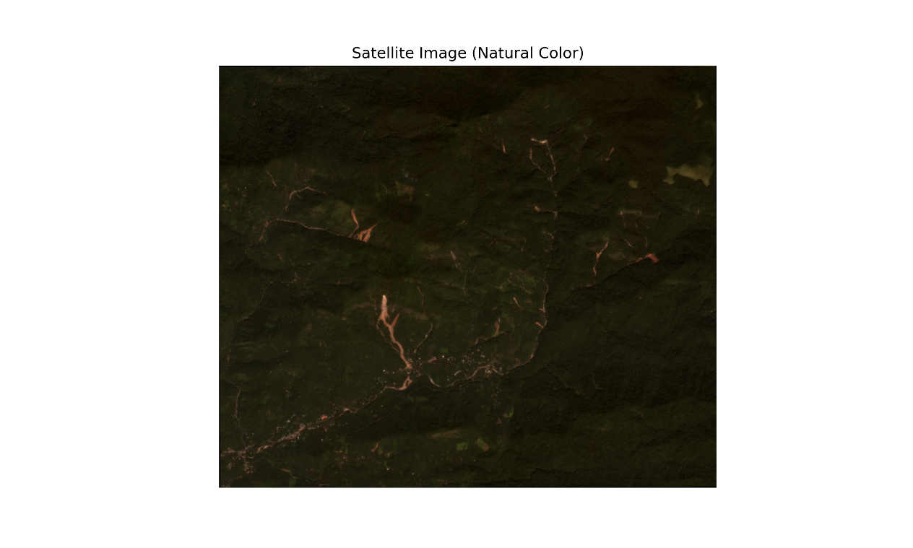
2022 PlanetScope AnalyticMS (Testing)
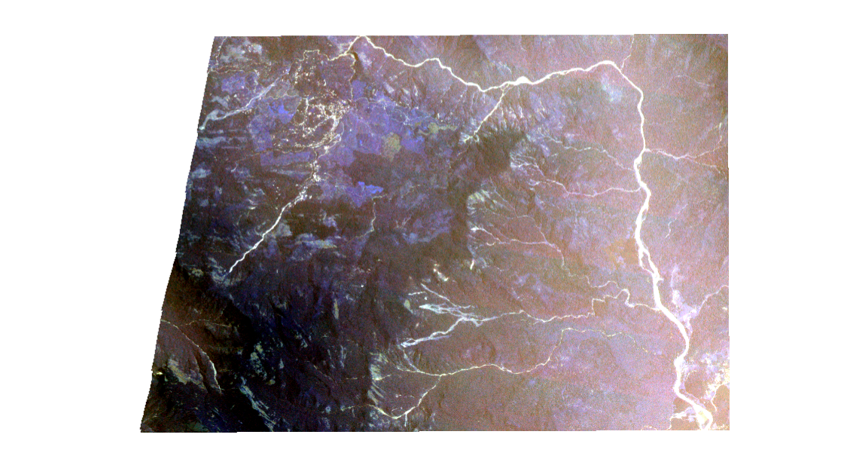
Prediction and Evaluation Visuals:-
Landslide prediction masks -
U-Net 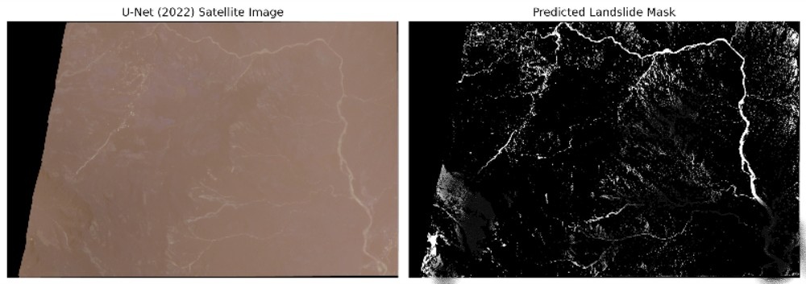
Res U Net
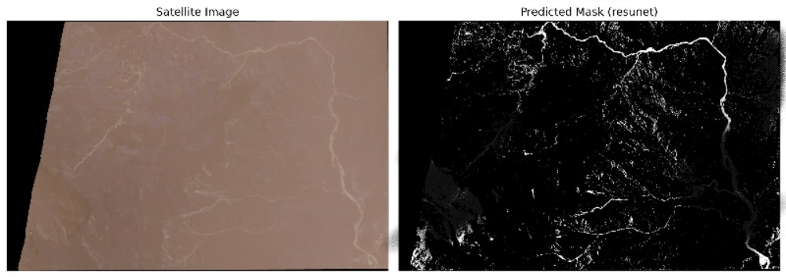
Atten U Net
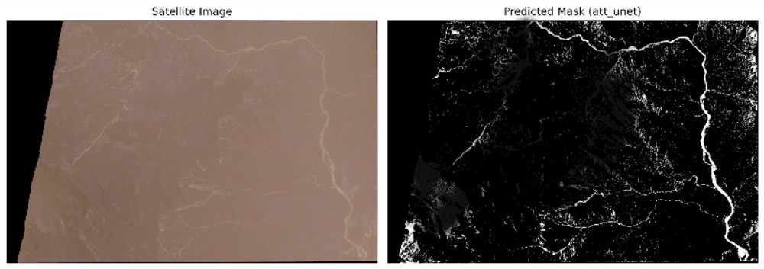
Atten Res U Net
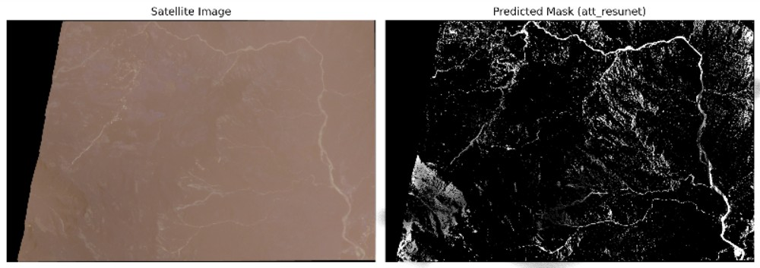
ASDMS U Net
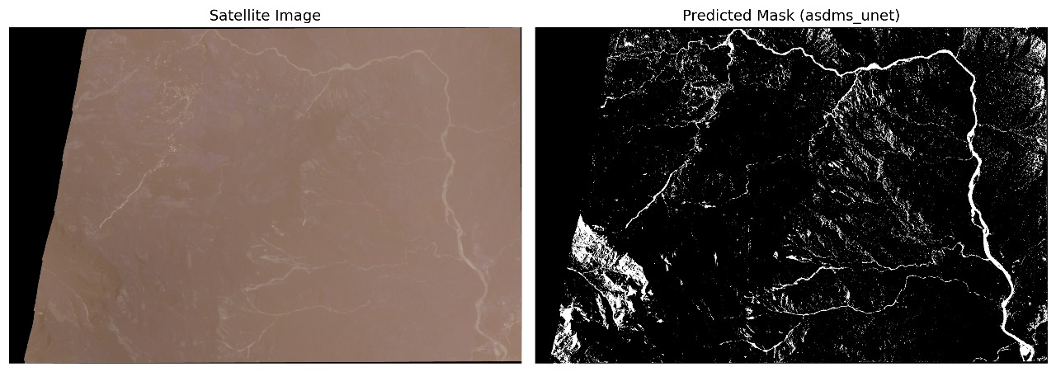
Confusion matrices:
U-Net
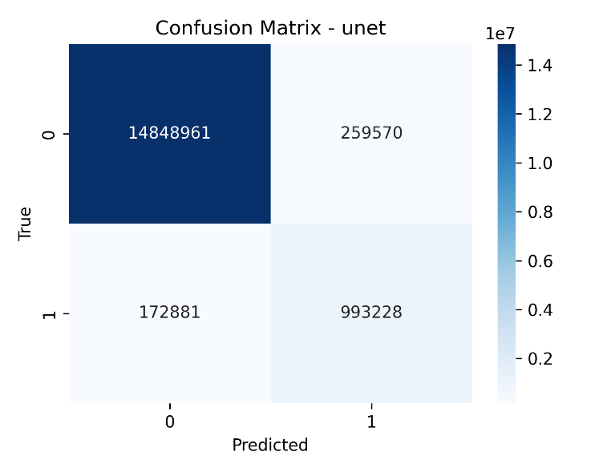
Res U Net
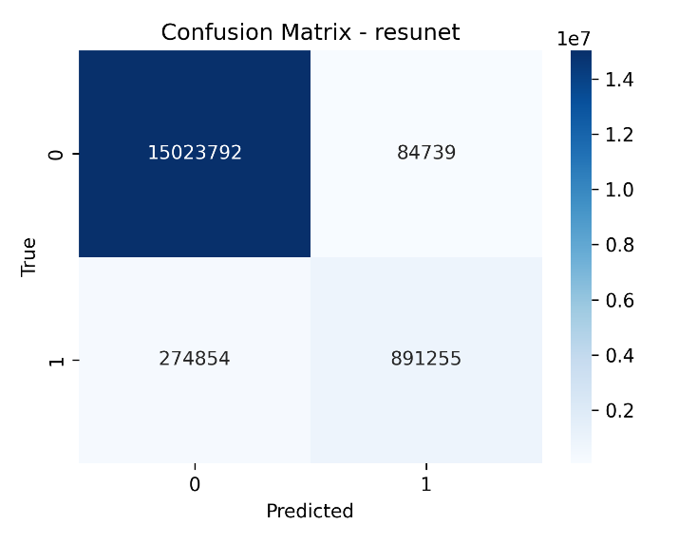
Atten U Net
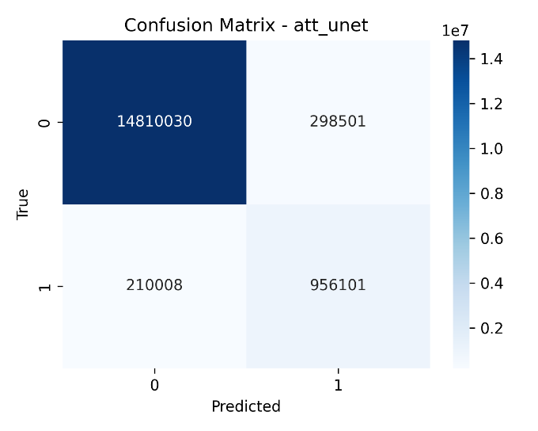
Atten Res U Net
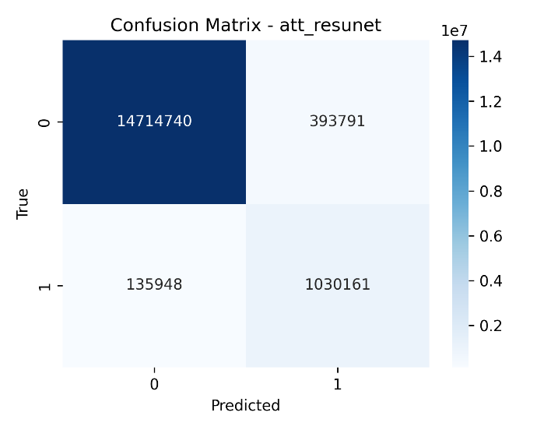
ASDMS U Net
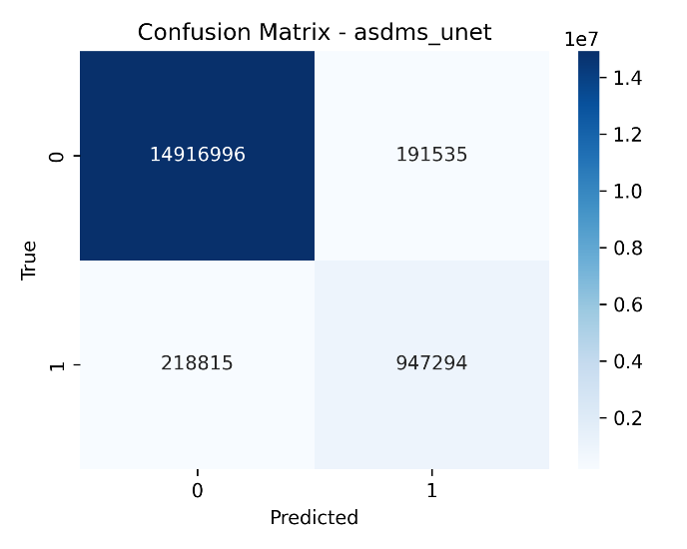
Bar chart comparing model performances:
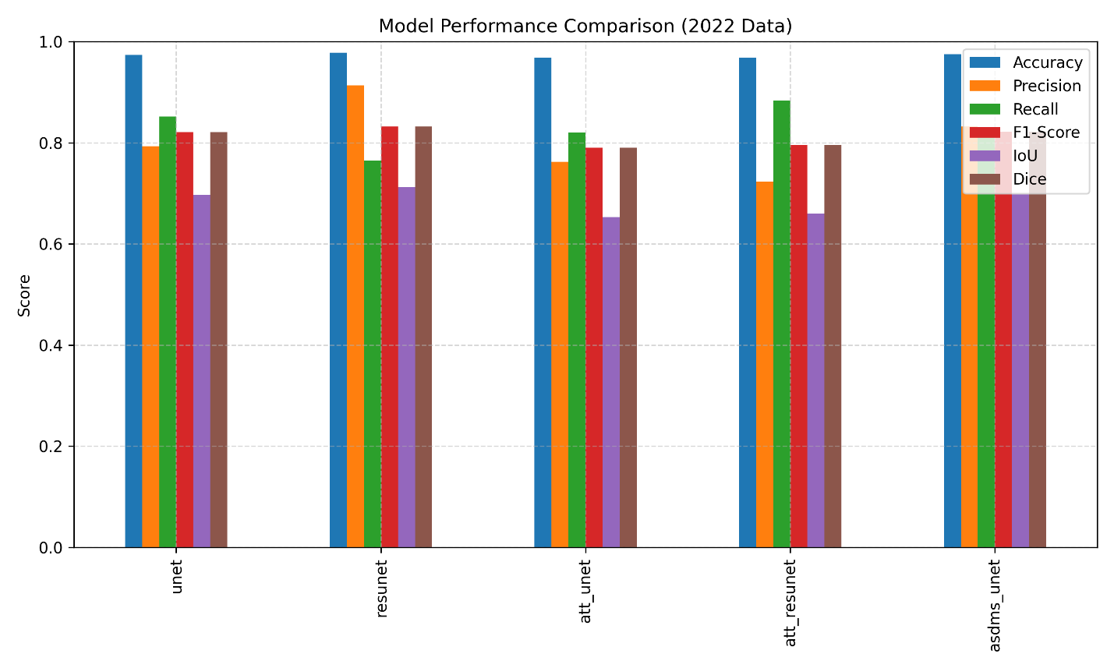

Discussions
Advantages
• Demonstrates robust cross-year generalization using residual-based architectures.
• Validates temporal transfer learning as a feasible strategy for geohazard mapping.
• Attention mechanisms enhance landslide sensitivity (recall improvement).
• ASDMS U-Net provides a balanced trade-off between accuracy and recall.
Challenges
• Slight overfitting in complex terrain features (Attention-based models).
• Performance drop in shadowed or vegetation-rich areas.
• Limited sample size (single study area) restricts spatial generalization.
Recommendations
• Extend dataset with multi-regional samples for spatial–temporal robustness.
• Integrate explainable AI (Grad-CAM) to interpret model focus zones.
• Experiment with Vision Transformers (ViT) or Swin-UNet for enhanced contextual learning.
• Include climate and topographic covariates for multi-modal modeling.

Conclusion
This study presents LTS-Net, a unified framework for evaluating temporal transfer learning in landslide segmentation using multispectral satellite imagery.
Through experiments on the Villangad dataset, it demonstrates that ResU-Net provides the best cross-year performance, confirming the effectiveness of residual and hybrid architectures in capturing terrain-invariant features.
The proposed framework establishes a strong baseline for future domain adaptation research in geohazard mapping and remote sensing analytics.

